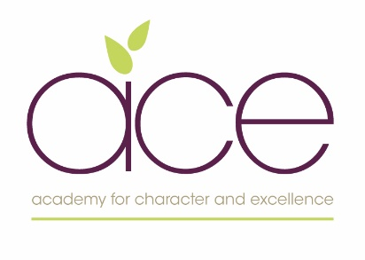

Coronavirus: visitor agreement

The School has a legal duty to follow relevant health and safety guidance. This information is being obtained and will be processed (as required) for the purposes of carrying out a task in the public interest and/or the legal obligation to keep anyone on the school site safe.
The information will only be shared with a public body if it is necessary to do so and required by law. It will be kept secure and securely disposed of when it is no longer needed. You may contact the School if you require further information in respect of how your information will be used.
By signing this document, I understand and agree that when visiting the school:
- I confirm that I do not currently need to self-isolate, in accordance with the latest government guidance
- I will follow the school’s hygiene practices (set out in the leaflet I have been given)
Should I experience coronavirus symptoms within 48 hours after leaving the school, I will notify the school. I will take a coronavirus test and notify the school of the result.
I understand that the school will keep these details for as long as reasonably required. Please note that we ordinarily would expect to securely dispose of this information within 21 days unless required to keep for longer in accordance with Government guidance.

Visitor’s full name
Visitor’s contact number
date of visit
Purpose of visit
Areas of school that will be visited
Visitor’s signature

