My Home Learning



Name………………………

Class………………….

Please make sure this file comes to school daily.

**Y6 Home Learning Expectations**

We ask our parents and carers to help, support and encourage their child to complete the home learning tasks that are set.

Our expectation for home learning in Year 6 is as follows:

* Daily reading.
* Reading diary completed by the child daily and signed by an adult at least once per week.
* Book review written after finishing each book.
* Complete two Maths activities on Quiz Shed per week, as set by the class teacher.
* Complete at least two sessions per week on Times Tables Rock Stars.
* Learn the 15 spellings from the list sent home and on Spelling Shed. Children will be tested the following week and re-tested on any they got wrong the previous week and the application of the words.

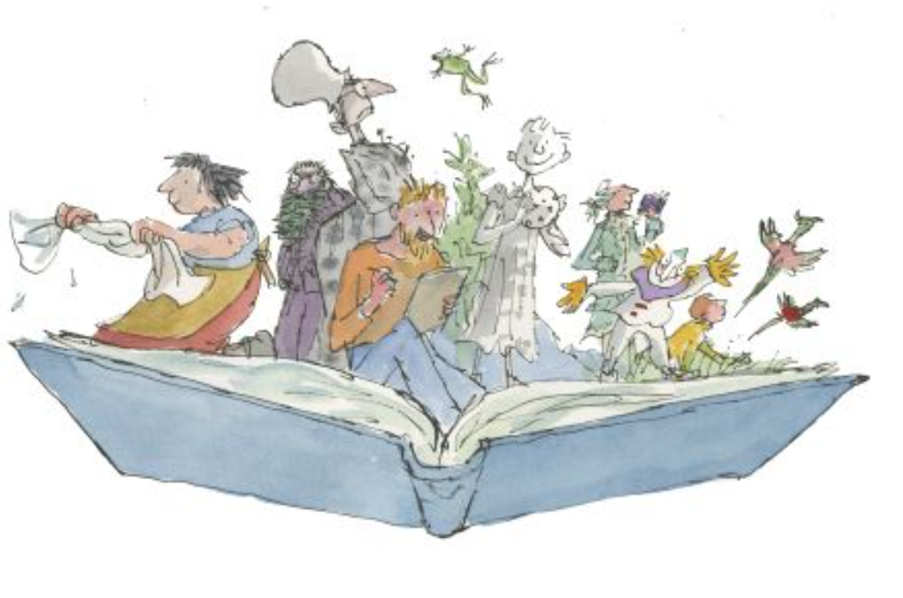

**Reading**



Learning to read is probably the most important part of your child’s learning at primary school. Reading helps children to understand things, it enables them to express their feelings and it fires their imagination.

Your child will make accelerated progress with their reading if they read at home, please find the time to read with them every day (for about 10 minutes).

Find a comfortable place to sit, encourage them to read the text but do not put too much pressure on them; you can always read to them or try again at another time.

They will also benefit from seeing you read. When you read you are showing them that reading matters and that it is something that brings *you* a lot of pleasure.

We ask all children to read daily at home and complete their reading diary. Please make sure you sign the diary, at least once a week, once you have discuss the book with your child. If you have any comments, please also add them.

**Questions to ask your child when reading**

# You can help your child to understand what they’re reading (reading comprehension) by asking them questions about what they’ve read and about what might happen next in the text. Here are some examples of the types of questions you might want to ask them during or after they’ve read with you:

* *Do you like this character? Why / why not?*
* *Which words best describe that character?*
* *How do you think that character felt when…?*
* 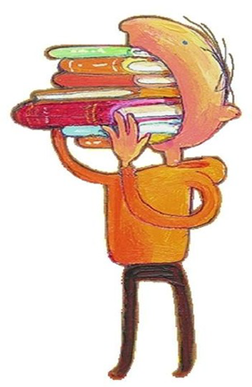*How did the story make you feel? Why?*
* *Where is this book set? How do you know?*
* *When do you think this story happened? Why do you think that?*
* *What do you think might happen next?*
* *Would you recommend this book to a friend? Why / why not?*

**What have you read over the school holidays?**

|  |
| --- |
|  |

**Spellings**

Children will have weekly spelling tests, these will be on a Friday. They will be given 15 spellings and tested a week later, they will then practise the spellings again the following week and apply them to sentences, they will be re-tested on any they got wrong the previous week and the application of the words.

Each year group has a set of key words to learn to spell, these words will also be covered through the weekly spellings.

|  |  |  |
| --- | --- | --- |
| **Spellings** | | |
| amateur | disastrous | persuade |
| apparent | embarrass | prejudice |
| awkward | exaggerate | privilege |
| bruise | existence | profession |
| category | familiar | pronunciation |
| committee | harass | queue |
| communicate | hindrance | recognise |
| conscience | interfere | rhyme |
| conscious | interrupt | rhythm |
| controversy | language | secretary |
| convenience | mischievous | signature |
| correspond | nuisance | vehicle |
| critic | occupy | yacht |
| criticise | occur |  |
| curiosity | opportunity |  |

**Maths**

Each week we ask the children to complete two activities on Quiz Shed, if you would prefer the paper copy that is fine too. These will be handed out or uploaded on a Friday and collected back in the following Thursday.

Times tables help to support the children build their maths knowledge and enable them to problem solve confidently and accurately. The children will also have times tables set on Times Tables Rock Stars for them to practise at least twice a week. They will also have weekly times tables tests to reinforce this.

In Key Stage 1 and Lower Key Stage 2, the children should have learnt all the times tables up to 12. It is important in years 5 and 6 to consolidate this allowing the children to rapidly recall both the multiplication and related division facts within 6 seconds.

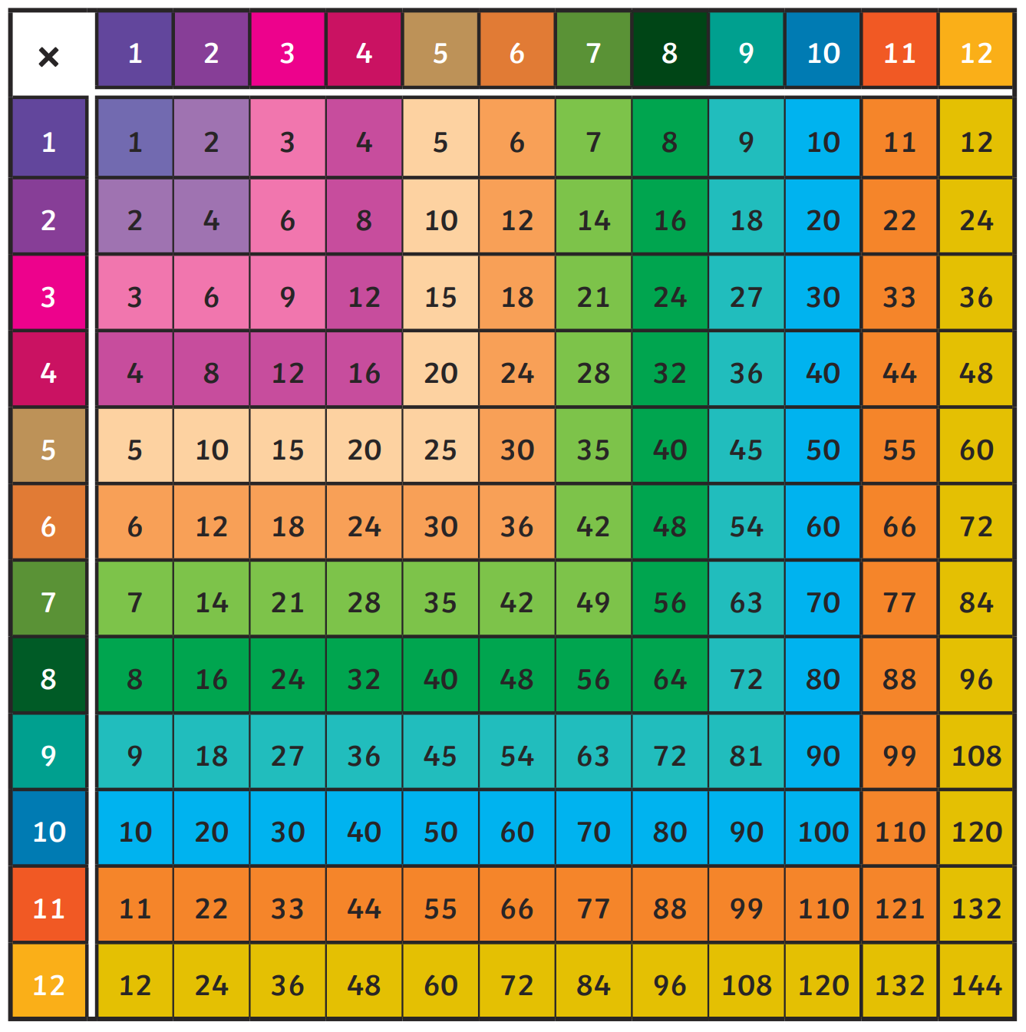

**End of Year 6 National Reading Expectations**

|  |
| --- |
| **Reading** |
| **Word Reading** |
| 1. Apply my knowledge of root words, prefixes and suffixes and a range of word origins to read aloud with appropriate inflection. |
| **Comprehension** |
| *Maintain positive attitudes to reading and understanding of what I read by:* |
| 2. Read and discuss an increasingly wide range of fiction, poetry, plays, non-fiction and reference books or textbooks, and be able to note authorial choice of plot, word use and characterisation. |
| 3. Read a range of text types and make links between the content and the structure of the text and suggest reasons why the author has chosen to do this. |
| 4. To have a known repertoire of or knowledge of a range of texts, including myths, legends & traditional stories, modern fiction, fiction from our literary heritage & books from other cultures & traditions. |
| 5. Recommend books that I have read to my peers, giving reasons for my choices and persuading others by noting key selling points about the text/book/author. |
| 6. Identifying and discussing themes and conventions in and across a wide range of writing, using quotes or examples from texts to support viewpoints. |
| 7. Making comparisons within and across books to directly compare theme, storyline, characters in a retrieved or inferred manner. |
| 8. Knowing a wide range of poetry by heart that includes favourite poets and some examples of a mix of poetic theme. |
| 9. Preparing classic poems and extracts of classic play works to read aloud and to perform, showing understanding through intonation, tone and volume so that the meaning is clear to an audience. |
| Understand what I read by: |
| 10. Developing an understanding of the deeper meanings within a book or text; discussing their understanding and exploring the meaning of words in context. |
| 11. Being proactive to discover hidden meanings or to develop meaning beyond what I understand already. |
| 12. Justifying all inference or deductions in relation to texts with evidence, making my idea or point clear and related to text-based evidence. |
| 13. Being able to predict plot and implications by referencing the author’s voice or intention clear within a text. |
| 14. Summarising key points from a text and justifying my choices. |
| 15. Explaining how a writer uses specific phrases or words to develop a meaning or message. |
| 16. Explaining and evidencing how an author’s choice impacts the reader. |
| 17. Distinguishing between implications of fact and opinion with reference to authorial voice or the statements made by characters within a text. |
| 18. Paraphrasing information from non-fiction sources. |
| 19. Leading or taking active part in discussions about books that are read to me and those I can read for myself, building on my and others’ ideas and challenging views courteously. |
| 20. Provide reasoned justifications for my views by making clear, structured arguments or statements with text-based evidence (across all genres and in spoken language). |

**End of Year 6 National Writing Expectations**

|  |
| --- |
| **Writing** |
| **Transcription: Spelling** |
| 1. Use further prefixes and suffixes and understand the guidelines for adding them. |
| 2. Distinguish between homophones and other words which are often confused. |
| 3. Use knowledge of morphology and etymology in spelling and understand that some spellings need to be learnt specifically. |
| 4. Use dictionaries to check the spelling and meaning of words. |
| 5. Use a thesaurus. |
| **Transcription: Handwriting** |
| 6. Write legibly, fluently and with increasing speed by: choosing the writing implement that is best suited for a task. |
| **Writing: Composition** |
| 7. Plan writing by: identifying the audience & purpose of the writing, selecting the appropriate form & using other similar writing as models for my own. |
| 8. Plan my writing by: noting and developing initial ideas, drawing on reading and research where necessary. |
| 9. Plan my writing by: in narratives considering how authors have developed characters and settings in what they have read, listened to or seen performed. |
| 10. Selecting appropriate grammar and vocabulary, understanding how such choices can change and enhance meaning. |
| 11. Draft and write by: in narratives, describing settings, characters and atmosphere and integrating dialogue to convey character and advance the action. |
| 12. Draft and write by: summarising longer passages. |
| 13. Draft and write by: using a wide range of devices to build cohesion within and across paragraphs. |
| 14. Evaluate and edit by: assessing the effectiveness of my own and others’ writing. |
| 15. Evaluate and edit by: proposing changes to vocabulary, grammar and punctuation to enhance effects and clarify meaning. |
| 16. Evaluate & edit by: ensuring correct subject-verb agreement when using singular & plural, distinguish between the language of speech and writing. |
| 17. Perform my own compositions using appropriate intonation, volume and movement so that meaning is clear. |
| **Writing: Vocabulary, Grammar and Punctuation** |
| 18. Recognise vocabulary and structures that are appropriate for formal speech and writing, including subjunctive forms. |
| 19. Use passive verbs to affect the presentation of information in a sentence. |
| 20. Use hyphens to avoid ambiguity. |
| 21. Use semi-colons, colons or dashes to mark boundaries between independent clauses and a colon to introduce a list. |
| 22. Punctuating bullet points consistently. |
| 23. Use ellipses. |
| 24. Learn the grammar and grammatical terminology for Stage 6: *formal and informal speech and writing, synonyms and antonyms.* |

**End of Year 6 National Maths Expectations**

|  |
| --- |
| **Maths** |
| **Place value** |
| 1. Read, write, order and compare numbers up to 10,000,000 and determine the value of each digit. Round any whole number to a required degree of accuracy. |
| 2. Use negative numbers in context, and calculate intervals across zero. Solve number and practical problems that involve all of the above. |
| **Addition, subtraction, multiplication and division** |
| 3. Multiply and divide numbers up to 4 digits by a 2-digit whole number using the formal written methods and interpret remainders as whole number remainders, fractions, or by rounding. |
| 4. Identify common factors, common multiples and prime numbers. |
| 5. Use my knowledge of the order of operations to carry out calculations involving the four operations. |
| 6. Solve addition and subtraction multi-step problems in contexts, deciding which operations and methods to use and why. |
| **Fractions** |
| 7. Use common factors to simplify fractions; use common multiples to express fractions in the same denomination. |
| 8. Add and subtract fractions with different denominators and mixed numbers, using the concept of equivalent fractions. |
| 9. Multiply simple proper fractions and simplify the answer (e.g. ¼ x ⅟₂ = ⅟₈). Divide proper fractions by whole numbers (e.g. ⅓ ÷ 2 = ⅙). |
| 10. Identify the value of each digit to three decimal places and multiply and divide numbers by 10, 100 and 1000 where the answers are up to three decimal places. |
| 11. Multiply one-digit numbers with up to two decimal places by whole numbers. Use written division methods in cases where the answer has up to two decimal places. |
| 12. Recall and use equivalences between simple fractions, decimals and percentages, including in different contexts. |
| **Reasoning and problem-solving** |
| 13. Solve problems involving the calculation of percentages (e.g. of measures) such as 15% of 360 and the use of percentages for comparison. |
| 14. Solve problems involving similar shapes where the scale factor is known or can be found. Solve problems involving unequal sharing and grouping using knowledge of fractions and multiples. |
| **Algebra** |
| 15. Express missing number problems algebraically. Use simple formulae expressed in words. |
| 16. Generate and describe linear number sequences. |
| 17. Find pairs of numbers that satisfy number sentences involving two unknowns. Enumerate all possibilities of combinations of two variables. |
| **Measure** |
| 18. Solve problems involving the calculation and conversion of units of measure, using decimal notation up to three decimal places where appropriate. Convert between miles and km. |
| 19. Use, read, write & convert between standard units of measure, converting length, mass, volume & time from smaller to larger units, and vice versa, using decimal notation to up to 3 decimal places. |
| 20. Recognise that shapes with the same areas can have different perimeters and vice versa. |
| 21. Calculate the area of parallelograms and triangles. Recognise when it is possible to use formulae for area and volume of shapes. |
| 22. Calculate, estimate and compare volume of cubes and cuboids using standard units, including centimetre cubed (cm3) and cubic metres (m3), and extending to other units. |
| **Geometry** |
| 23. Draw 2-D shapes using given dimensions and angles. Recognise, describe and build simple 3-D shapes, including making nets. |
| 24. Compare and classify geometric shapes based on their properties and sizes and find unknown angles in any triangles, quadrilaterals, and regular polygons. |
| 25. Illustrate and name parts of circles, including radius, diameter and circumference and know that the diameter is twice the radius. |
| 26. Recognise angles where they meet at a point, are on a straight line, or are vertically opposite, and find missing angles. |
| **Position and direction** |
| 27. Describe positions on the full coordinate grid (all four quadrants). |
| 28. Draw and translate simple shapes on the coordinate plane, and reflect them in the axes. |
| **Statistics** |
| 29. Interpret and construct pie charts and line graphs and use these to solve problems. |
| 30. Calculate and interpret the mean as an average. |

**Curriculum Based Learning**

Each half term we ask the children to complete one piece of home learning based around their big question, this will be added to the file.



