My Home Learning File



Name………………………

Class………………….

Please make sure this file comes to school daily.

**Y5 Home Learning Expectations**

We ask our parents and carers to help, support and encourage their child to complete the home learning tasks that are set.

Our expectation for home learning in Year 5 is as follows:

* Daily reading at home.
* Reading diary completed by the child daily and signed by an adult at least once per week.
* Book review written after finishing each book.
* Complete one Maths activity on Quiz Shed per week, as set by the class teacher.
* Complete at least two sessions per week on Times Tables Rock Stars.
* Learn the 15 spellings from the list sent home and on Spelling Shed. Children will be tested the following week and re-tested on any they got wrong the previous week and the application of the words.

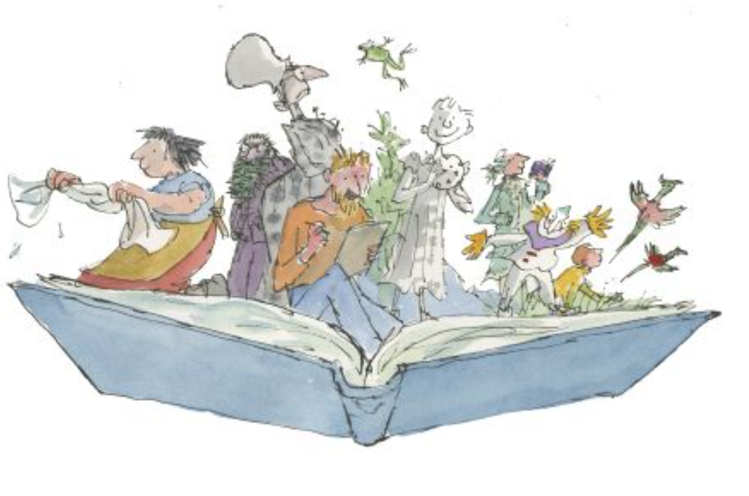

**Reading**



Learning to read is probably the most important part of your child’s learning at primary school. Reading helps children to understand things, it enables them to express their feelings and it fires their imagination.

Your child will make accelerated progress with their reading if they read at home, please find the time to read with them every day (for about 10 minutes).

Find a comfortable place for them to sit, encourage them to read the text but do not put too much pressure on them; you can always read to them or try again at another time.

They will also benefit from seeing you read. When you read you are showing them that reading matters and that it is something that brings *you* a lot of pleasure.

We ask all children to read daily at home and complete their reading diary. Please make sure you sign the diary, at least once a week, once you have discuss the book with your child. If you have any comments, please also add them.

**Questions to ask your child when reading**

# You can help your child to understand what they’re reading (reading comprehension) by asking them questions about what they’ve read and about what might happen next in the text. Here are some examples of the types of questions you might want to ask them during or after they’ve read with you:

* *Do you like this character? Why / why not?*
* *Which words best describe that character?*
* *How do you think that character felt when…?*
* 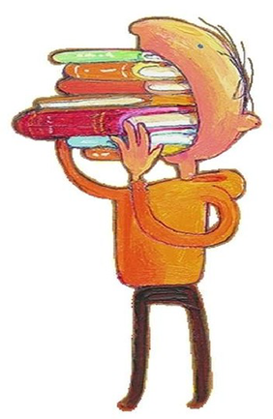*Do you think you’re anything like any of the characters? Why?*
* *How did the story make you feel? Why?*
* *Where is this book set? How do you know?*
* *When do you think this story happened? Why do you think that?*
* *Have you learnt anything about the world from this book?*
* *What do you think might happen next?*
* *Would you recommend this book to a friend? Why / why not?*

**What have you read over the school holidays?**

|  |
| --- |
|  |

**Spellings**

Children will have weekly spelling tests and these will be on a Friday. They will be given 15 spellings and tested a week later. They will then practise the spellings again during the following week and apply them to sentences. They will be re-tested on any they got wrong the previous week and the application of the words.

Each year group has a set of key words to learn to spell, these words will also be covered through the weekly spellings.

|  |  |  |
| --- | --- | --- |
| **Spellings** | | |
| accommodate | equipped | physical |
| accompany | equipment | programme |
| according | especially | recommend |
| achieve | excellent | relevant |
| aggressive | explanation | restaurant |
| ancient | foreign | sacrifice |
| appreciate | forty | shoulder |
| attached | frequently | sincere |
| available | government | sincerely |
| average | guarantee | soldier |
| bargain | identity | stomach |
| cemetery | immediate | sufficient |
| community | immediately | suggest |
| competition | individual | symbol |
| definite | leisure | system |
| desperate | lightning | temperature |
| determined | marvellous | thorough |
| develop | muscle | twelfth |
| dictionary | necessary | variety |
| environment | neighbour | vegetable |
| equip | parliament |  |

**Maths**

Each week we ask the children to complete one activity on Quiz Shed, if you would prefer the paper copy that is fine too. These will be handed out or uploaded on a Friday and collected back in on the following Thursday.

Times tables help to support the children build their maths knowledge and enable them to problem solve confidently and accurately. The children will also have times tables set on Times Tables Rock Stars for them to practise at least twice a week. They will also have weekly times tables tests to reinforce this.

In Key Stage 1 and Lower Key Stage 2, the children should have learnt all the times tables up to 12. It is important in years 5 and 6 to consolidate this, allowing the children to rapidly recall both the multiplication and related division facts within 6 seconds.

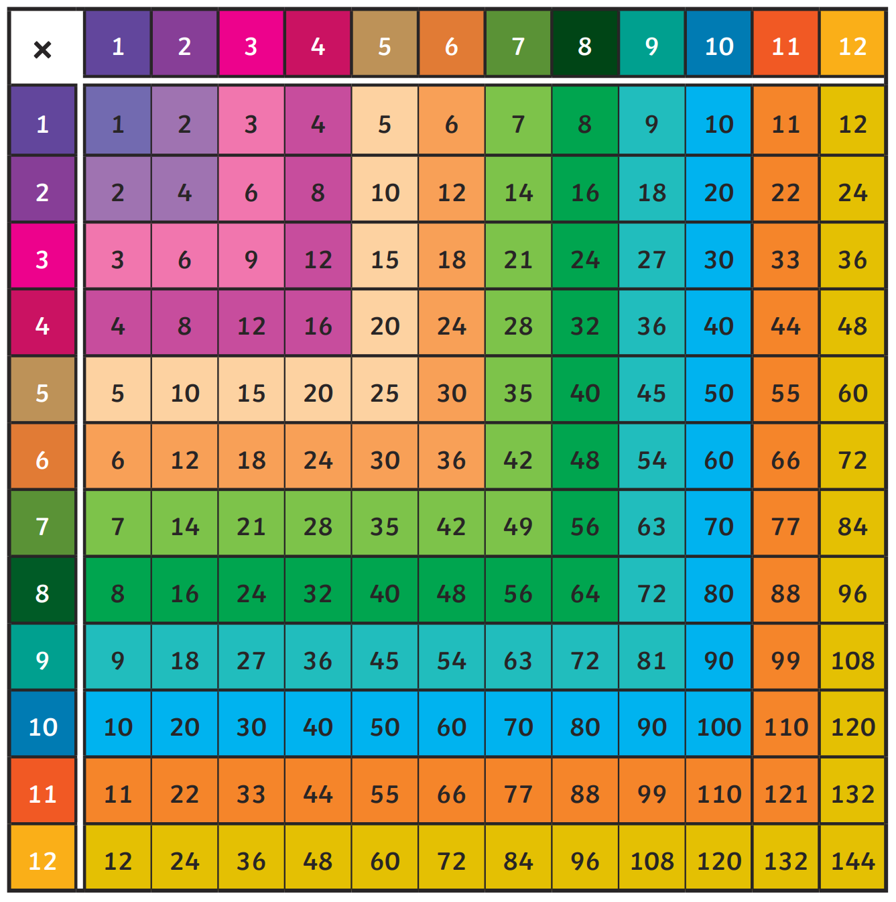

**End of Year 5 National Reading Expectations**

|  |
| --- |
| **Reading** |
| **Word reading** |
| 1. Apply my growing knowledge of root words, prefixes and suffixes (morphology and etymology) both to read aloud and to understand the meaning of new words that I meet. |
| **Comprehension** |
| *Maintain positive attitudes to reading and understanding of what they read by:* |
| 2. Continue to read and discuss an increasingly wide range of fiction, poetry, plays, non-fiction and reference books or textbooks. |
| 3. Read books that are structured in different ways and read for a range of purposes; including non- linear (flashbacks, out of order story telling), classic (Dickens etc) and modern (graphic novels, adventure and crime) narrative styles. |
| 4. Increase my familiarity with a wide range of books, including myths, legends & traditional stories, modern fiction, fiction from our literary heritage & books from other cultures & traditions. |
| 5. Recommend books that I have read to my peers, giving reasons for my choices. |
| 6. Identifying and discussing themes and conventions in and across a wide range of writing. |
| 7. Make comparisons within and across books. |
| 8. Learn a wider range of poetry by heart. |
| 9. Prepare poems and plays to read aloud and to perform, showing understanding through intonation, tone and volume so that the meaning is clear to an audience. |
| *Understand what I read by:* |
| 10. Checking that the book makes sense to me, discussing my understanding and exploring the meaning of words in context. |
| 11. Asking questions to improve my understanding of a text. |
| 12. Drawing inferences such as inferring characters’ feelings, thoughts and motives from their actions, and justifying inferences with evidence; compare with other texts. |
| 13. Predicting and justifying what might happen from details stated and implied and give reasons why. |
| 14. Summarising the main ideas drawn from more than one paragraph, identifying key details that support the main ideas. |
| 15. Identifying how language, structure and presentation contribute to meaning. |
| 16. Discuss and evaluate how authors use language, including figurative language, considering the impact on the reader. |
| 17. Distinguish between statements of fact and opinion. |
| 18. Retrieve, record and present information from a range of non-fiction sources. |
| 19. Participate in discussions about books that are read to me and those I can read for myself, building on my own and others’ ideas and challenging views courteously. |
| 20. Explain and discuss my understanding of what I have read, including through formal presentations and debates, maintaining a focus on the topic and using notes where necessary. |
| 21. Provide reasoned justifications for my views. |

**End of Year 5 National Writing Expectations**

|  |
| --- |
| **Writing** |
| **Transcription: Spelling** |
| 1. Use further prefixes and suffixes and understand the guidance for adding them. |
| 2. Spell some words with silent letters. |
| 3. Continue to distinguish between homophones and other words which are often confused. |
| 4. Use dictionaries to check the spelling and meaning of words and use a thesaurus. |
| 5. Use the first three or four letters of a word to check spelling, meaning or both of these in a dictionary. |
| **Transcription: Handwriting** |
| 6. Write legibly, fluently and with increasing speed by: choosing which shape of a letter to use when given choices and deciding whether or not to join specific letters. |
| 7. Write legibly, fluently and with increasing speed by: choosing the writing implement that is best suited for a task. |
| **Writing: Composition** |
| 8. Plan my writing by: identifying the audience for & purpose of the writing, selecting the appropriate form & using other similar writing as models. |
| 9. Plan my writing by: noting and developing initial ideas drawing on reading and research where necessary. |
| 10. Draft and write by: selecting appropriate grammar and vocabulary. |
| 11. Draft and write by: using a range of devices to build cohesion within paragraphs. |
| 12. Draft and write by: using further organisational and presentational devices to structure text and to guide the reader. |
| 13. Evaluate and edit by: assessing the effectiveness of my own writing and others by giving specific examples. |
| 14. Evaluate and edit by: proposing changes to vocabulary, grammar and punctuation to enhance effects. |
| 15. Evaluate and edit by: ensuring the consistent and correct use of tense throughout a piece of writing. |
| 16. Evaluate & edit by: ensuring correct subject-verb agreement when using singular & plural, distinguish between the language of speech & writing. |
| 17. Proof-read for spelling and punctuation errors. |
| **Writing: Vocabulary, Grammar and Punctuation** |
| 18. Use the perfect form of verbs to mark relationships of time and cause. |
| 19. Use expanded noun phrases to convey complicated information concisely. |
| 20. Use modal verbs or adverbs to indicate degrees of possibility. |
| 21. Use relative clauses beginning with who, which, where, when, whose, that or with an implied (i.e. omitted) relative pronoun. |
| 22. Use commas to clarify meaning or avoid ambiguity in writing. |
| 23. Use brackets, dashes or commas to indicate parenthesis. |
| 24. Learn the grammar for Stage 5. Use & understand the Stage 5 grammatical terminology. |

**End of Year 5 National Maths Expectations**

|  |
| --- |
| **Maths** |
| **Place value** |
| 1. Read, write, order & compare numbers to at least 1, 000, 000 and determine the value of each digit. |
| 2. Count forwards or backwards in steps of powers of 10 for any given number up to 1 000 000. Round any number up to 1 000 000 to the nearest 10, 100, 1000, 10 000 and 100 000. |
| 3. Interpret negative numbers in context, count forwards and backwards with positive and negative whole numbers through zero. |
| 4. Read Roman numerals to 1000 (M) and recognise years written in Roman numerals. |
| **Addition and subtraction** |
| 5. Add and subtract whole numbers with more than 4 digits, including using formal written methods (columnar addition and subtraction). |
| 6. Add and subtract numbers mentally with increasingly large numbers. Use rounding to check answers to calculations and levels of accuracy. |
| 7. Solve addition and subtraction multi-step problems in contexts, deciding which operations and methods to use and why. |
| Multiplication and division |
| 8. Identify multiples and factors, including finding all factor pairs of a number, and common factors of two numbers. |
| 9. Know and use the vocabulary of prime numbers, prime factors and composite (non-prime) numbers. Establish whether a number up to 100 is prime and recall prime numbers up to 19. |
| 10. Multiply numbers up to 4 digits by a 1- or 2-digit number using a formal written method. Divide numbers up to 4 digits by a 1-digit number using the formal written method of short division. |
| 11. Multiply and divide whole numbers and those involving decimals by 10, 100 and 1000. |
| 12. Recognise and use square numbers and cube numbers, and the notation for squared and cubed. |
| **Fractions** |
| 13. Compare and order fractions whose denominators are all multiples of the same number. Add and subtract fractions with the same denominator and multiples of the same number. |
| 14. Identify, name and write equivalent fractions of a given fraction, represented visually, including tenths and hundredths. |
| 15. Recognise mixed numbers and improper fractions and convert from one form to the other and write mathematical statements > 1 as a mixed number. |
| 16. Multiply proper fractions and mixed numbers by whole numbers, supported by materials and diagrams. |
| 17. Round decimals with two decimal places to the nearest whole number and to one decimal place. Read and write decimal numbers as fractions (e.g. 0.72 = ⁷²∕₁₀₀). |
| 18. Read, write, order and compare numbers with up to three decimal places. Solve problems involving number up to three decimal places. |
| 19. Write percentages as a fraction. Solve problems which require knowing percentage and decimal equivalents of ⅟₂, ⅟₄, ⅟₅, ⅖, ⅘ and those with a denominator of a multiple of 10 or 25. |
| **Measure** |
| 20. Convert between different units of metric measure (e.g. kilometre and metre; centimetre and metre; centimetre and millimetre; gram and kilogram; litre and millilitre). |
| 21. Measure & calculate the perimeter of composite rectilinear shapes in cm/m. Calculate the area of squares/rectangles using standard units, square cm/m and estimate the area of irregular shapes. |
| 22. Estimate volume (e.g. using 1 cm blocks to build cubes/cuboids) and capacity (e.g. using water). |
| 23. Solve problems involving converting between units of time. Use all four operations to solve problems involving measure (e.g. length, mass, volume, money) using decimal notation including scaling. |
| **Geometry** |
| 24. Identify 3D shapes, including cubes and other cuboids, from 2D representations. |
| 25. Know angles are measured in degrees: estimate and compare acute, obtuse and reflex angles. Draw given angles, and measure them in degrees. |
| 26. Identify: angles at a point and one whole turn (total 360⁰); angles at a point on a straight line and ½ a turn (total 180⁰); other multiples of 90⁰. |
| 27. Use the properties of rectangles to deduce related facts and find missing lengths and angles. |
| 28. Identify, describe and represent the position of a shape following a reflection or translation, using the appropriate language, and know that the shape has not changed. |
| **Statistics** |
| 29. Solve comparison, sum and difference problems using information presented in a line graph. |
| 30. Complete, read and interpret information in tables, including timetables. |

**Curriculum Based Learning**

Each half term we ask the children to complete one piece of home learning based around their big question, this will be added to the file.



