My Home Learning File



Name………………………

Class………………….

Please make sure this file comes to school daily.

**Y4 Home Learning Expectations**

We ask our parents and carers to help, support and encourage their child to complete the home learning tasks that are set.

Our expectation for home learning in Year 4 is as follows:

* Daily reading (and discussion about the book) to or with an adult at home.
* Reading diary completed by the child daily and signed by an adult at least once per week.
* Book review written after finishing each book.
* Complete one Maths activity on Quiz Shed per week, as set by the class teacher.
* Complete at least two sessions per week on Times Tables Rock Stars.
* Learn the 15 spellings from the list sent home, children will be tested the following week, and retested the week after with either the spellings with errors or applying the words.

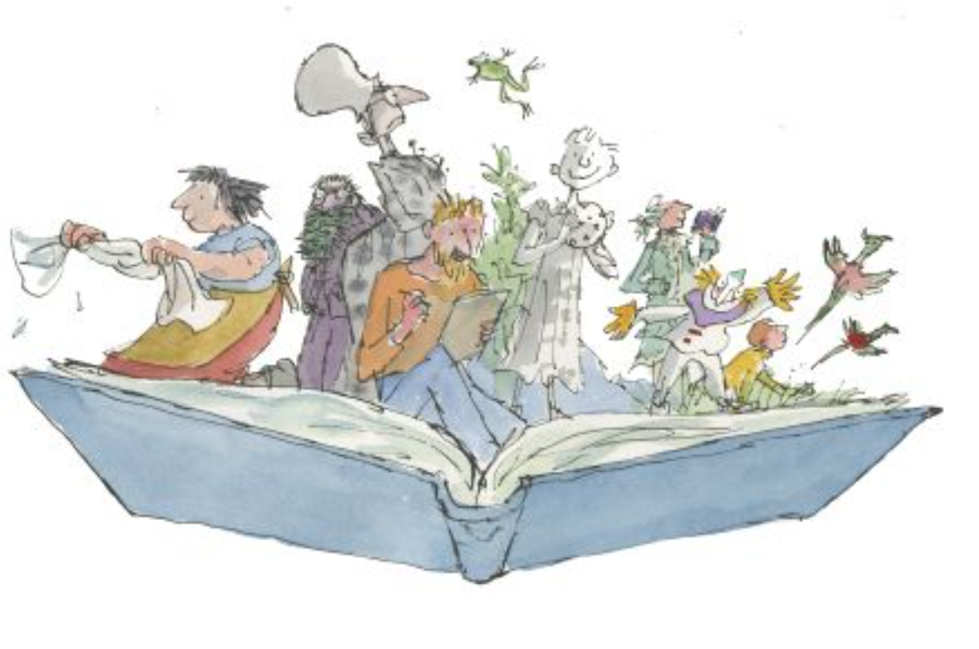

**Reading**



Learning to read is probably the most important part of your child’s learning at primary school. Reading helps children to understand things, it enables them to express their feelings and it fires their imagination.

Your child will make accelerated progress with their reading if you **find the time to read with them every day** (for about 10 minutes).

Find a comfortable place to read with your child. Encourage them to read the text but do not put too much pressure on them; you can always read to them or try again at another time (see the alternative ways to read with your child on the next page).

They will also benefit from seeing you read. When you read you are showing them that reading matters and that it is something that brings *you* a lot of pleasure.

We ask all children to read daily at home. Please make sure you sign the diary once you have red with your child. If you have any comments, please also add them.

**Questions to ask your child when reading**

# You can help your child to understand what they’re reading (reading comprehension) by asking them questions about what they’ve read and about what might happen next in the text. Here are some examples of the types of questions you might want to ask them during or after they’ve read with you:

* *Do you like this character? Why / why not?*
* *Which words best describe that character?*
* *Which words tell us that...?*
* *How do you think that character felt when…?*
* 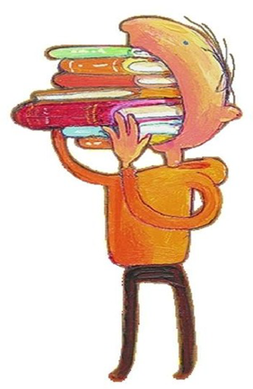*How did the story make you feel? Why?*
* *Where is this book set? How do you know?*
* *When do you think this story happened? Why do you think that?*
* *What do you think might happen next?*
* *Would you recommend this book to a friend? Why / why not?*

**What have you read over the school holidays?**

|  |
| --- |
|  |

**End of Year 4 National Reading Expectations**

|  |
| --- |
| **Reading** |
| **Word reading** |
| 1. I can apply my growing knowledge of root word, prefixes and suffixes (etymology and morphology) both to read aloud and to question and understand the meaning of new words I meet. |
| 2. I can read and spell further exception words, noting the unusual correspondences between spelling and sound, and where these occur in the word. |
| **Comprehension** |
| *Develop positive attitudes to reading and understanding of what I read by:* |
| 3. I can listen to and give preferences for a wide range of fiction, poetry, plays, nonfiction and reference or text books; giving reasons. |
| 4. I can read books that are structured in different ways and read for a range of purposes with increasing independence. |
| 5. I can use a dictionary to check the meaning of words I have read including using a thesaurus to find synonyms. |
| 6. I have increased my familiarity with a wide range of books, including fairy stories, myths and legends, and retelling some of these orally from alternate narrative viewpoints. |
| 7. I can independently identify themes and conventions in a wide range of books. |
| 8. I can prepare a range of poems and play scripts to read aloud and to perform, showing understanding through intonation, tone, volume and action. |
| 9. I can discuss word and phrases that capture the reader’s interest and imagination and why an author would have used them. |
| 10. I can state some opinions about different forms of poetry (e.g. free verse, narrative poetry), giving examples. |
| *Understand what I have read, in books they can read independently by:* |
| 11. I can check that the text makes sense to me, discussing my understanding and explaining the meaning of words in context. |
| 12. I can ask inference and deduction questions to improve my understanding of a text. |
| 13. I can draw inferences such as inferring characters’ feelings, thoughts and motives from their actions, and justifying inferences with evidence with plausible reasons. |
| 14. I can predict what might happen from details stated and implied. |
| 15. I can identify main ideas drawn from more than one paragraph and summarise these. |
| 16. I can develop the ability to identify how language, structure and presentation contributes to meaning. |
| 17. I can retrieve and record increasingly more relevant information from non-fiction texts. |
| 18. I can participate in discussion about both books that are read to me and those that I can read myself, taking turns and listening to what others say. |

**Spellings**

Children will have weekly spelling tests, these will be on a Friday. They will be given new spellings fortnightly and tested a week later, they will then practice the spellings again the following week and apply them to sentences, they will be re-tested on any they got wrong the previous week and the application of the words.

Each year group has a set of key words to learn to spell, these words will also be covered through the weekly spellings.

|  |  |  |
| --- | --- | --- |
| **Spellings** | | |
| actual | experiment | peculiar |
| actually | extreme | perhaps |
| address | favourite | popular |
| appear | forward | position |
| believe | forwards | possess |
| bicycle | grammar | possession |
| breath | guard | possible |
| breathe | guide | potatoes |
| busy | heard | pressure |
| business | height | probably |
| calendar | imagine | promise |
| caught | increase | purpose |
| centre | interest | recent |
| century | knowledge | regular |
| complete | library | sentence |
| consider | material | separate |
| continue | medicine | special |
| difficult | mention | strange |
| disappear | natural | strength |
| earth | notice | suppose |
| enough | opposite | surprise |
| exercise | ordinary | therefore |
| experience | particular | various |

**End of Year 4 National Writing Expectations**

|  |
| --- |
| **Writing** |
| Spelling |
| 1. I can use further prefixes and suffixes and understand how to add them. |
| 2. I can spell further homophones and near homophones. |
| 3. I can spell words that are often misspelt in my own writing. |
| 4. I can use the first two or three letters of a word to check its spelling in a dictionary independently. |
| 5. I can write from memory sentences that include words and punctuation taught so far (from the full Year 3 and 4 list). |
| Handwriting |
| 6. I can understand which letters, when adjacent to one another, are best left un-joined. |
| 7. I can increase the legibility, consistency and quality of my handwriting (my lines of writing are spaced so that ascenders and descenders of letters do not touch). |
| Writing—Composition |
| 8. I can plan writing by discussing writing similar to that which I’m planning to write, to learn from its structure, vocab and grammar. |
| 9. I can draft and write by composing and rehearsing sentences orally, progressively building a varied and rich vocabulary and an increasing range of sentences structures. |
| 10. I can organise paragraphs around a theme. |
| 11. In narratives, I can create settings, characters and plot applied across a range of genres. |
| 12. In non-narrative material, I can use a range of organisational devices such as headings and sub-headings. |
| 13. I can evaluate and edit by assessing the effectiveness of my own and others’ writing and suggesting improvements. |
| 14. I can evaluate and edit by proposing changes to grammar and vocabulary to improve consistency, including the accurate use of pronouns in sentences. |
| 15. I can proof-read for spelling and punctuation errors with increasing independence. |
| 16. With increasing confidence, I can read aloud my own writing to a group or whole class, using appropriate intonation and controlling tone and volume so that the meaning is clear. |
| Writing—vocabulary, grammar and punctuation |
| 17. I can extend the range of sentences with more than one clause by using a wider range of conjunctions, adverbs or prepositions. |
| 18. I can choose nouns or pronouns appropriately for clarity and cohesion and to avoid repetition e.g. the noun is appropriately replaced by the pronoun ‘he’, ‘him’, ‘his’, etc. |
| 19. I can use conjunctions, adverbs and prepositions to express time and cause with increasing effect. |
| 20. I can use Year 4 grammar including plural and possessive –s, verb inflections. |
| 21. I can use fronted adverbials followed by commas. |
| 22. I can indicate possession by using the possessive apostrophe with plural nouns. |
| 23. I can use and punctuate direct speech using inverted commas and other punctuation: a comma after reporting clause, end punctuation within inverted commas. |
| 24. I can use and understand the grammatical terminology for Stage 4. |

**Maths**

Each week we ask the children to complete one activity on Math Shed, if you would prefer the paper copy that is fine too. These will be handed out or uploaded on a Friday and collected back in on the following Thursday.

Times tables help to support the children build their maths knowledge and enable them to problem solve confidently and accurately.

In Key Stage 1, the children should have learnt, and be fluent in the 2, 5 and 10 times tables, as well as the 3, 4 and 8 times tables, which they have practiced throughout year 3. In year 4 the children focus on the 6,7,9,11 and 12 times tables. It is important that the children also learn the related division facts and are able to recall these within 6 seconds.

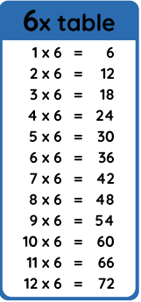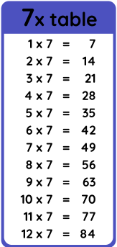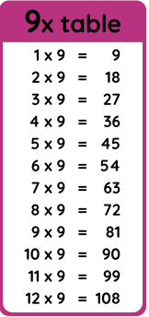

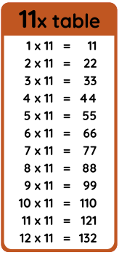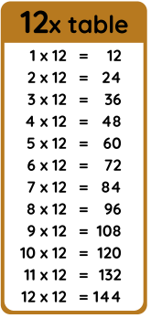

**End of Year 4 National Maths Expectations**

|  |
| --- |
| **Maths** |
| **Place value** |
| 1. I can count in multiples of 6, 7, 9, 25 and 1,000 |
| 2. I can find 1,000 more or less than a given number |
| 3. I can count backwards through zero to include negative numbers |
| 4. I can recognise the place value of each digit in a four-digit number (1,000s, 100s, 10s and 1s) and order and compare numbers beyond 1,000 |
| 5. I can read Roman numerals to 100 (I to C) and know that over time, the numeral system changed to include the concept of zero and place value |
| **Addition and subtraction** |
| 6. I can add and subtract numbers with up to 4 digits using the formal written methods of columnar addition and subtraction where appropriate |
| 7. I can estimate and use inverse operations to check answers to a calculation |
| 8. I can solve addition and subtraction two-step problems in contexts, deciding which operations and methods to use and why. |
| 9. I can recall multiplication and division facts for multiplication tables up to 12 × 12 |
| 10. I can recognise and use factor pairs and commutativity in mental calculations |
| **Multiplication and division** |
| 11. I can multiply two-digit and three-digit numbers by a one-digit number using formal written layout |
| 12. I can solve problems involving multiplying and adding, including using the distributive law to multiply two-digit numbers by 1 digit, integer scaling problems and harder correspondence problems such as n objects are connected to m objects. |
| **Fractions** |
| 13. I can recognise and show, using diagrams, families of common equivalent fractions |
| 14. I can count up and down in hundredths; recognise that hundredths arise when dividing an object by a 100 and dividing tenths by 10. |
| 15. I can add and subtract fractions with the same denominator |
| 16. I can recognise and write decimal equivalents of any number of tenths or hundredths; and the decimal equivalents to ¼; ½; ¾ |
| 17. I can find the effect of dividing a one- or two-digit number by 10 and 100, identifying the value of the digits in the answer as ones, tenths and hundredths |
| 18. I can round decimals with 1 decimal place to the nearest whole number and solve simple measure and money problems involving fractions and decimals to 2 decimal places. |
| **Measure** |
| 19. I can convert between different units of measure (e.g. Kilometre to metre). I can solve problems involving converting from hours to minutes, minutes to seconds, years to months, weeks to days |
| 20. I can measure and calculate the perimeter of a rectilinear figure (including squares) in cm and metres and I can find the area of rectilinear shapes by counting squares |
| 21. I can estimate, compare and calculate different measures, including money in pounds and pence |
| 22. I can read, write and convert time between analogue and digital 12 and 24-hourclocks |
| **Geometry** |
| 23. I can compare and classify geometric shapes, including quadrilaterals and triangles, based on their properties and sizes |
| 24. I can identify acute and obtuse angles and compare and order angles up to 2 right angles by size |
| 25. I can identify lines of symmetry in 2-D shapes presented in different orientations |
| 26. I can complete a simple symmetric figure with respect to a specific line of symmetry. |
| 27. I can describe positions on a 2-D grid as coordinates in the first quadrant. I can  describe movements between positions as translations of a given unit to the left/right and up/down |
| 28. I can plot specified points and draw sides to complete a given polygon |
| **Statistics** |
| 29. I can interpret and present discrete and continuous data using appropriate graphical methods, including bar charts and time graphs |
| 30. I can solve comparison, sum and difference problems using information presented  in bar charts, pictograms, tables and other graphs. |

**Curriculum Based Learning**

Each half term we ask the children to complete one piece of home learning based around their big question, this will be added to the file.



