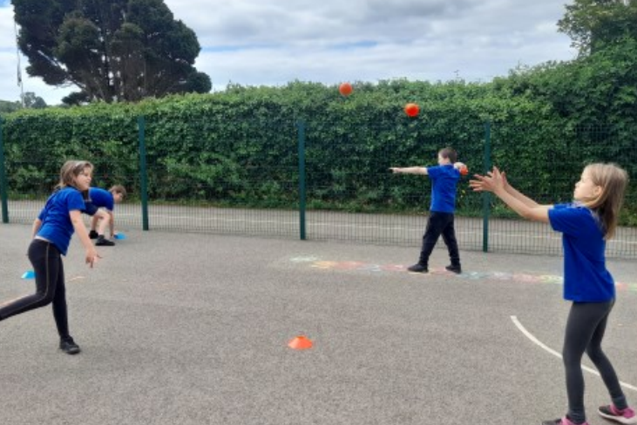
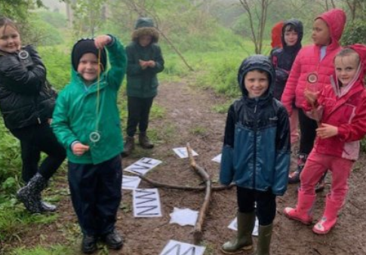
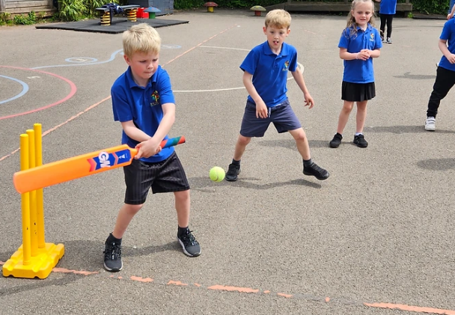

Primary Physical Education and Sport Premium Plan and Evaluation 2023 - 2024

Brixham C of E Primary School

The following document is a working document to outline the intended expenditure of PPESP for the 2023 – 2024 academic year. Throughout the year, the actions completed will be evidenced and evaluated.
Support for review and reflection - considering the 5 key indicators from DfE, what development needs are a priority for your setting and your students now and why? Use the space below to reflect on previous spend, identify current need and priorities for the future.

Key achievements to date: | Areas for further improvement and baseline evidence of need:
See Plan and Evaluation 2022/2023 for full overview:  - Active lunchtimes through the use of external coach.  - Consistent PE CPD for staff through the use of external coach.  - Offer of extra-curricular activities. | The following are areas which we look to further develop in this academic year:  - Increase the daily exercise for pupils in line with health guidance (30 minutes daily), especially through organised play during break and lunchtimes.  - Provide further professional development for staff through linking with a professional organisation, linking to the school’s progressive PE curriculum.  - Increase free opportunities for pupils to attend extra-curricular activities outside of school hours.

Meeting national curriculum requirements for swimming and water safety | Please complete all of the below:
What percentage of your current Year 6 cohort swim competently, confidently and proficiently over a distance of at least 25 metres?  N.B. Even though your children may swim in another year please report on their attainment on leaving  primary school. | Will be updated in Summer 2024 following final assessment.
What percentage of your current Year 6 cohort use a range of strokes effectively [for example, front crawl, backstroke and breaststroke]? | Will be updated in Summer 2024 following final assessment.
What percentage of your current Year 6 cohort perform safe self-rescue in different water-based situations? | Will be updated in Summer 2024 following final assessment.
Schools can choose to use the Primary PE and Sport Premium to provide additional provision for swimming but this must be for activity over and above the national curriculum requirements. Have you used it in this way? | -

Action Plan and Budget Tracking
Capture your intended annual spend against the 5 key indicators. Clarify the success criteria and evidence of impact that you intend to measure to evaluate for students today and for the future.

Academic Year: 2023/2024 |  | Total fund allocated: £18,110 | Date Updated: September 2023
Key indicator 1: The engagement of all pupils in regular physical activity – Chief Medical Officer guidelines recommend that primary school children undertake at least 30 minutes of physical activity a day in school  Key indicator 2: The profile of PESSPA being raised across the school as a tool for whole school improvement  Key indicator 3: Increased confidence, knowledge and skills of all staff in teaching PE and sport  Key indicator 4: Broader experience of a range of sports and activities offered to all pupils  Key indicator 5: Increased participation in competitive sport |  |  |  |  | Percentage of total allocation:
 |  |  |  |  | %100 Planned for
School focus with clarity on intended impact on pupils: | K.I | Actions to achieve: | Funding allocated: | Evidence and impact:  Ongoing update: Next update Dec 2023 | Sustainability and suggested next steps:
Kinetic Sport Group for x1 afternoon a week  - Active lunch and play leader support  - CPD for PE delivery  - Free club for children | 1  2  3  4  5 | - Develop a new group of play leaders who can support active play at lunchtimes.  - Work alongside teachers for PE delivery and planning  - Provide a free club for pupils to access. | £5,785
Saints South West  - Free club for KS1 pupils | 4 | - Saints South West to provide x2 coaches to deliver a free KS1 club  - Target key pupil groups to attend. | £2100  x2 coaches
Door Step Arts  - Introduction of a free performing arts club for KS2 | 4 | - Door Steps Art to provide a free club for KS2 pupils, working towards termly performances. | £1,980
Further PE Support  - Qualified PE teacher to support PE delivery | 3 | - Qualified PE teacher employed to deliver and support staff in planning the school’s PE curriculum. | £4,725
Sports Equipment  - Replenishing equipment in line with PE delivery | 3 | - Equipment inventory to be completed  - Order equipment required to deliver clubs and PE curriculum. | £2000
PE Clothing/kits  - Raise profile of PE with staff PE uniform and kits for teams | 2 | - Order PE uniform for staff teaching PE and running clubs  - Order team kits for football and netball teams. | £1500

