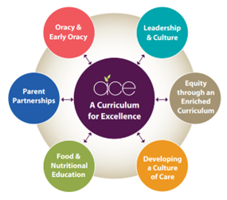
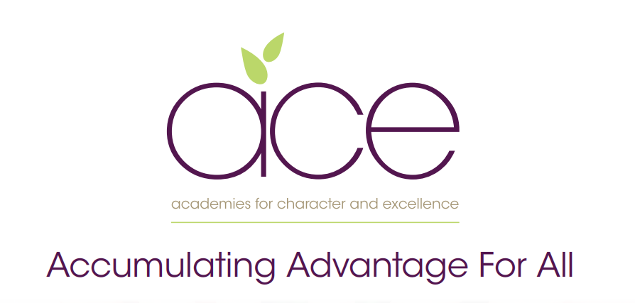

Brixham C of E Primary School Pupil premium strategy statement
2021–2024

This statement details our school’s use of pupil premium funding to help improve the attainment of our disadvantaged pupils. It outlines our pupil premium strategy, how we intend to spend the funding in this academic year and the effect that last year’s spending of pupil premium had within our school.

School overview

Detail | Data
School name | Brixham C of E
Number of pupils in school | 234
Proportion (%) of pupil premium eligible pupils | 27%
Academic year/years that our current pupil premium strategy plan covers (3 year plans are recommended) | 2021-2024
Date this statement was published | November 2021
Date on which it will be reviewed | November 2023
Statement authorised by | Governing Body
Pupil premium lead | Ben Nelson-Smith
Governor / Trustee lead | Cath Hayden / Paul Pickett

Funding overview

Detail |  | Amount
Pupil premium funding allocation this academic year | £80,330
Recovery premium funding allocation this academic year | 0
Pupil premium funding carried forward from previous years (enter £0 if not applicable) | 0
Total budget for this academic year  If your school is an academy in a trust that pools this funding, state the amount available to your school this academic year | £80,330

Part A: Pupil premium strategy plan

- See our Trust wide plan ‘Accumulating Advantage for all’
In a changing world we recognise the need to ensure that our Curriculum reflects how pupils are supported and encouraged to flourish in all aspects of their lives. Current research shows that the South West is one of the most challenging areas to grow up poor. We strongly believe that as a Trust, and through our Curriculum, we are able to narrow the disadvantaged gap, supporting all pupils.

Our aims for our disadvantaged pupils

- Our aim as a Trust is to ensure that all pupils accumulate advantage based on the high quality experience that we offer them through our Curriculum and enquiry based approach to learning.

- Our Curriculum is rich and ambitious and offers all pupils an equal opportunity to experience a range of outdoor lessons, take part in educational visits, theatre trips, hands-on days, expert visits and have the opportunity to explore a wide range of extra-curricular clubs.

- We believe that all pupils should have the opportunity to aspire to be the best version of themselves, therefore we provide pupils with the experiences that develop their love of learning and support them to acquire experiences as they move through their school lives, to make informed choices when deciding future decisions.

Statement of Intent

At the heart of our curriculum lie three core values: pursuit of academic excellence; the explicit teaching of learning to learn, which includes the development of metacognition; and crucially, character education. We believe that through our curriculum and core principles we can ensure that our very high expectations result in improved outcomes for disadvantaged pupils. This ensures all children will achieve and flourish whilst acquiring life longs skills that enable learners to overcome any barriers to learning and future successes.

Objectives for our disadvantaged Pupils

- We will ensure that the progress of our disadvantaged children will equal or exceed those who are not disadvantaged by implementing our strategy plan. The ACE curriculum plays a central and critical role in accumulating advantage for all pupils, including those that are presently or previously experiencing disadvantage.

- All disadvantaged pupils will be equipped, academically, socially, culturally and emotionally to continue to make progress at their Secondary schools and beyond. Our aim is to ensure that all children leaving our schools are successful learners, curious explorers and healthy thinkers.

Our current pupil premium plan focuses on the following goals (see ‘Accumulating advantage for all’ booklet for more detail)

Strong Leadership that drives:
- Equity through an enriched curriculum (including high quality, well researched and impactful interventions)
- A culture of high quality care
- Food and Nutritional Education
- Effective parent/carer partnerships
- Development of Early Oracy and ongoing oracy skills

Challenges

This details the key challenges to achievement that we have identified among our disadvantaged pupils.
Challenge number | Detail of challenge
1 | Many children have weak oral language skills on entry, including limited vocabulary, affecting their spoken language, comprehension and, later, their writing. This has increased since the pandemic
2 | Covid-19 lockdowns negatively affected children’s knowledge and skills in English and mathematics (lost learning) and exacerbated existing difficulties.
3 | For some children, their social, emotional and mental health (SEMH) needs negatively affect their learning.
4 | Some children lack resilience for learning and, during Covid-19 lockdowns, lost the resilience they had previously gained.
5 | Lack of parental support and knowledge about how to provide such support for their children are barriers to the progress of some children.
6 | Poor attendance and punctuality are barriers for some children.

Intended outcomes - see ‘Accumulating Advantage for all’

Intended outcome | Success criteria
- A Curriculum for Excellence  The ACE curriculum is ensuring QFT is making a difference for our disadvantaged pupils and progress measures show the gap between disadvantaged and others is closing | - As a result of careful and focused monitoring our PP pupils are becoming successful learners  - Journals reflect progress made in all the areas- metacognition, character education and academic excellence  - progress of non-disadvantaged pupils and no greater than a 10% difference
- Oracy  All disadvantaged pupils have improved oracy skills and are increasingly able to communicate effectively | - Language link programme demonstrates improved language skills  - Oracy approach (across the curriculum) is evident in terms of key outcomes for pupils  - PP children are read with daily, prioritised by class teachers and TA’s. - Pre-teach of vocabulary is introduced to children and explained prior to provide more opportunities for children to be successful. - Vocabulary is explicitly taught through quality first teaching and is planned for by class teachers.
- Enrichment opportunities are providing pupils with the skills and knowledge to become more successful learners | - Take up of BC and ASCs has increased and pupils are gaining through these experiences  - All disadvantaged pupils attend residentials / trips
- High quality care through SEMH support is ensuring excellent wellbeing and readiness for learning | - Pupil outcomes have improved in all areas (academically, socially, emotionally, culturally)  - Pastoral support is well matched to individual need
- Food and Nutrition  Pupils and families have opportunities in school to participate in workshops and clubs to improve health through food and nutrition education | - PP children are well fed in school, they have good access to food and being hungry is never an issue  - Breakfast and snacks are provided where necessary
- Parent/carer partnerships are strong and parents are increasingly able to support their children’s well being and learning | - Improve attendance of disadvantaged pupils to 95%

Activity in this academic year

Teaching (for example, CPD, recruitment and retention)
Budgeted cost: £12675
Activity | Evidence that supports this approach | Challenge number(s) addressed
Quality First Teaching.  CPD will ensure that all teachers have a good understanding of metacognition to support the children’s learning and allowing them to think about their learning | https://educationendowmentfoundation.org.uk/education-evidence/guidance-reports/metacognition | 1 ,2, 3, 4, 5,6
CDP  Ensure all support staff are added value to the classroom. TA’s will support the independence of children ensuring maximum progress and support from class teacher | https://educationendowmentfoundation.org.uk/education-evidence/guidance-reports/teaching-assistants | 1,2,3,4,5,6
Curriculum Planning  Ensuring all learning experiences are engaging and meet the interests of the pupils | https://educationendowmentfoundation.org.uk/support-for-schools/school-planning-support | 1,2,3,4,5,6

Targeted academic support (for example, tutoring, one-to-one support structured interventions)

Budgeted cost: £61025
Activity | Evidence that supports this approach | Challenge number(s) addressed
Targeted interventions for PP children to fill gaps, including pre-teaching and Reading Boosters and Reading tutors | https://educationendowmentfoundation.org.uk/education-evidence/teaching-learning-toolkit/teaching-assistant-interventions  +4 months | 1,2,3,4,5,6
Training for new staff on how to deliver Read Write Inc | Implementing a systematic programme (ERF) | 1,2,4,
Collaboration with English Hub to continually review and support provision for PP children in phonics. | Early Reading Framework – Section 5: Building a team of experts | 1,2,4
1:1 fluency intervention | EEF – improving literacy at KS2 | 1,2,4
SENCO supports targeted support plans for individual PP pupils delivered by support staff. | EEF – Follow the Asses, Plan, Do, Review process | 1,2,3,4,5,6

Wider strategies (for example, related to attendance, behaviour, wellbeing)
Budgeted cost: £6630

Activity | Evidence that supports this approach | Challenge number(s) addressed
Deliver high-quality physical education to support mental and physical well-being | EEF – Physical Activity & Self-regulation | 3,4
Safeguarding lead to support families with parenting support, workshops, and Early Help | EEF – parental engagement | 3,4
SEMH interventions and brain breaks | EEF - Self Regulation | 3,4
Breakfast at school runs daily for disadvantaged for time to talk and food. Physical activities also take place | EEF – Magic Breakfast Club | 3,4,5
Targeted pastoral support for children in need. | EEF - Wellbeing and Mental Health | 3,4,5

Total budgeted cost: £80,330

Part B: Review of outcomes in the previous academic year

Pupil premium strategy outcomes

Findings relating to our disadvantaged pupils were as follows:

Data shows;

EYFS
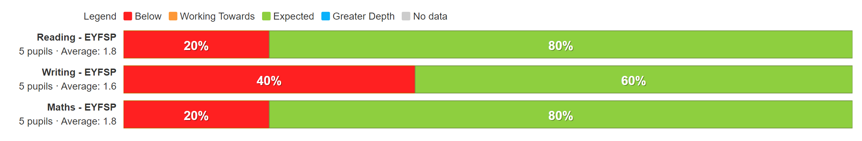
Year 1
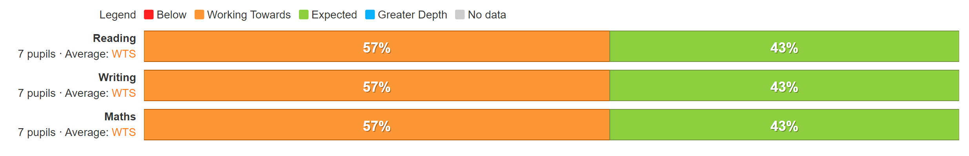
Year 2
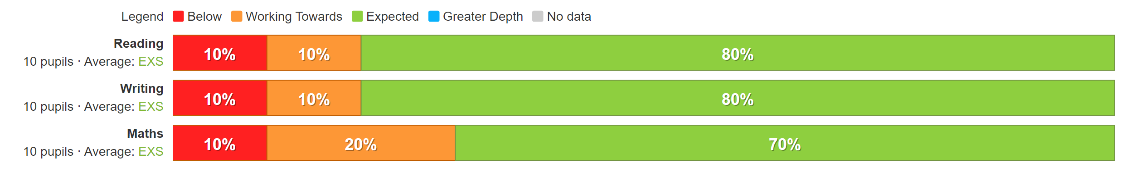
Year 3
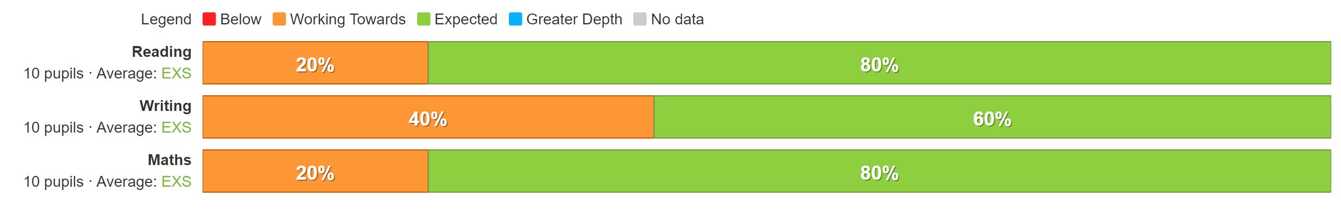
Year 4
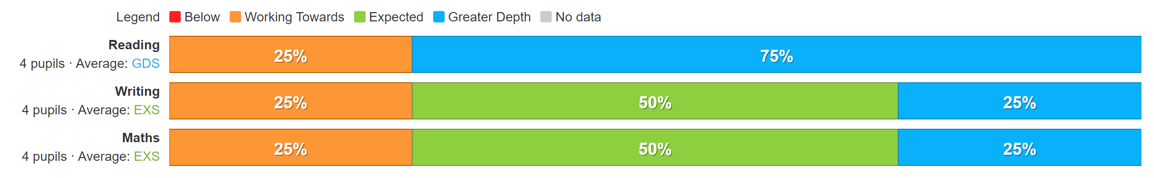

Year 5
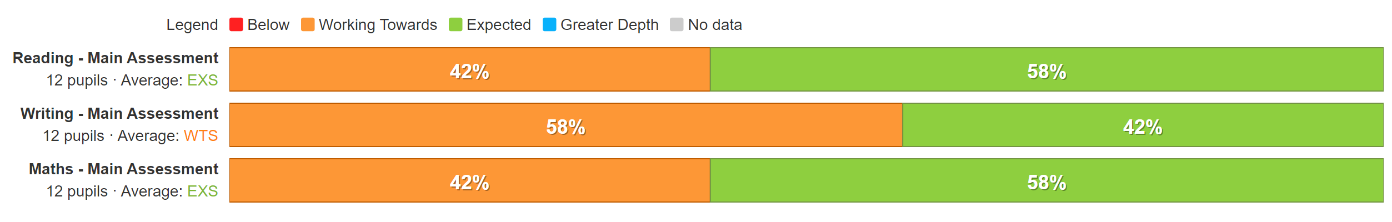

Year 6
