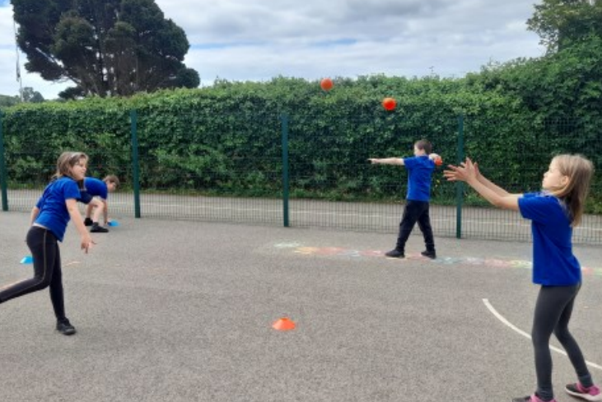
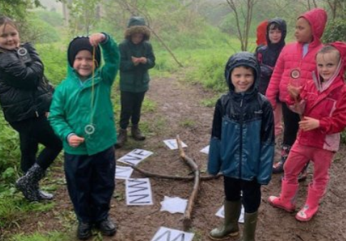
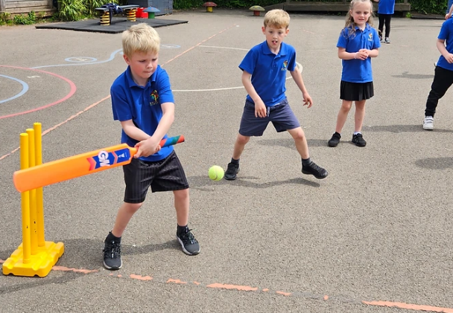

Primary Physical Education and Sport Premium Plan and Evaluation 2022 - 2023

Brixham C of E Primary School

The following document is a working document to outline the intended expenditure of PPESP for the 2022 – 2023 academic year. Throughout the year, the actions completed will be evidenced and evaluated.
Support for review and reflection - considering the 5 key indicators from DfE, what development needs are a priority for your setting and your students now and why? Use the space below to reflect on previous spend, identify current need and priorities for the future.

Key achievements to date: | Areas for further improvement and baseline evidence of need:
See Plan and Evaluation 2021/2022 for full overview:  - Building of a new running/cycle path to increase daily exercise and cycling proficiency.  - KS1 Bicycles/balance bikes have been purchased for use around the track.  - Most children have attended a sports festival in the year groups.  - Forest School set up has increased to include an outdoor classroom and further established grounds.  - Our Extra-curricular clubs offer increased.  - School teams have been developed, supported by new kits for pupils and staff. | The following are areas which we look to further develop in this academic year:  - Increase the daily exercise for pupils in line with health guidance (30 minutes daily), especially through organised play during break and lunchtimes.  - Provide further professional development for staff through linking with a professional organisation  - Increase opportunities for pupils to attend extra-curricular activities outside of school hours.

Meeting national curriculum requirements for swimming and water safety | Please complete all of the below:
What percentage of your current Year 6 cohort swim competently, confidently and proficiently over a distance of at least 25 metres?  N.B. Even though your children may swim in another year please report on their attainment on leaving  primary school. | 90%
What percentage of your current Year 6 cohort use a range of strokes effectively [for example, front crawl, backstroke and breaststroke]? | 90%
What percentage of your current Year 6 cohort perform safe self-rescue in different water-based situations? | 90%
Schools can choose to use the Primary PE and Sport Premium to provide additional provision for swimming but this must be for activity over and above the national curriculum requirements. Have you used it in this way? | -

Action Plan and Budget Tracking
Capture your intended annual spend against the 5 key indicators. Clarify the success criteria and evidence of impact that you intend to measure to evaluate for students today and for the future.

Academic Year: 2022/2023 |  | Total fund allocated: £18,110 | Date Updated: June 2022
Key indicator 1: The engagement of all pupils in regular physical activity – Chief Medical Officer guidelines recommend that primary school children undertake at least 30 minutes of physical activity a day in school  Key indicator 2: The profile of PESSPA being raised across the school as a tool for whole school improvement  Key indicator 3: Increased confidence, knowledge and skills of all staff in teaching PE and sport  Key indicator 4: Broader experience of a range of sports and activities offered to all pupils  Key indicator 5: Increased participation in competitive sport |  |  |  |  | Percentage of total allocation:
 |  |  |  |  | %100 Planned for
School focus with clarity on intended impact on pupils: | K.I | Actions to achieve: | Funding allocated: | Evidence and impact:  Ongoing update: Next July 2023 | Sustainability and suggested next steps:
Increase knowledge and skills of staff in delivering effective PE lessons  - Staff to work alongside PE specialist to develop knowledge of effective delivery | 3 | - Identify needs of staff support required – area of PE with less confidence.  - Arrange for external support to specifically work alongside staff.  - Work with professional to create medium term plan for staff members – e.g. co-teaching parts of the lesson.  - Assess impact on staff through the delivery of PE | £18,110  The full amount of the total fund allocated is used (with further school funding input) on employing a full time sport specialist from Kinetic Sports.  This person’s time and funding covers all of the school’s focus and actions on the left. | - Staff work with the PE lead to develop their understanding on planning and delivery.  - Lessons are more consistent across the school progression greater through improving school level abilities.  - Full year of PE coverage delivered across all year groups. | - Introduction of internal member of staff to lead PE so that the wider aspects of the curriculum (character and metacognition) can be planned for and delivered.
Increase pupils’ offer to experience a range of sporting activities through ‘Outdoor Learning’. Support mental and physical well-being of pupils. | 1  2  3  4 | - Timetable Forest school trained expert to develop internal member of staff  - Timetable every class across the school to experience Forest School throughout the year  - Develop long term plan which incorporates the school’s progression of metacognition |  | - All pupils access the forest school and have the opportunities to develop outdoor education skills, alongside the school’s metacognition.  - Pupils, on half-term rota, benefit from an extended whole morning outdoor ed lesson. As a result, pupils are more active and develop further team work.
Increase participation in extra-curricular clubs for families. | 1  2  4  5 | - Organise a timetable where a range of clubs can be accessed by families.  - Increase the opportunities for free clubs for families.  - Create a system where pupils can rotate through the year to reach maximum opportunities for all. |  | - The Summer term has seen an increase in extra-curricular clubs available to families. | Use the Sports premium to provide more clubs that are free, removing financial barriers for families.
Increase the number of minutes that pupils are active for throughout the school day. | 1 | - Organise break time and lunchtime activities which encourage pupils to learn new games and be more active.  - Introduce ‘Maths on the Move’ to increase active learning, whilst developing fluency.  - Generate a PE timetable where PE lessons are prioritised in the school curriculum. |  | - More pupils are involved in active playtimes due to PE specialist presence and organisation. Pupils are learning new skills and being more active. | Development of Play Leader Role for pupils. This will provide sustainability through pupils taking a lead and not being dependent on adults.

